**Voyage Vista: Illuminating Insights from Uber Expenditionary Analysis.**

**I. INTRODUCTION**

**1.1 Overview :**

Uber is a multinational transportation network company that operates a ride-hailing platform. It was founded in 2009 by Garrett Camp and Travis Kalanick and is based in San Francisco, California. Uber provides a convenient way for individuals to request rides from drivers who use their own personal vehicles.

Uber Driver Analysis refers to the Analyzing the number of trips taken by Uber drivers can provide insights into their overall activity and the demand for rides in specific areas. Daily, Weekly, or Monthly Analysis: Uber's data can be analyzed on a daily, weekly, monthly basis to understand the trends and patterns of trip volumes.

**1.2 Purpose :**

This analysis can help identify peak hours or days of high demand and optimize driver availability during those times. Trips can be analyzed based on geographic regions or specific cities to identify areas with higher demand.

This analysis can help Uber drivers decide where to focus their driving efforts for maximum efficiency and profitability. The Major of our project is to use data Analyzing techniques to find unknown patterns in the Uber Drives dataset.

**2. Problem Definition and Design Thinking:**

**2.1 EMPATHY MAP:**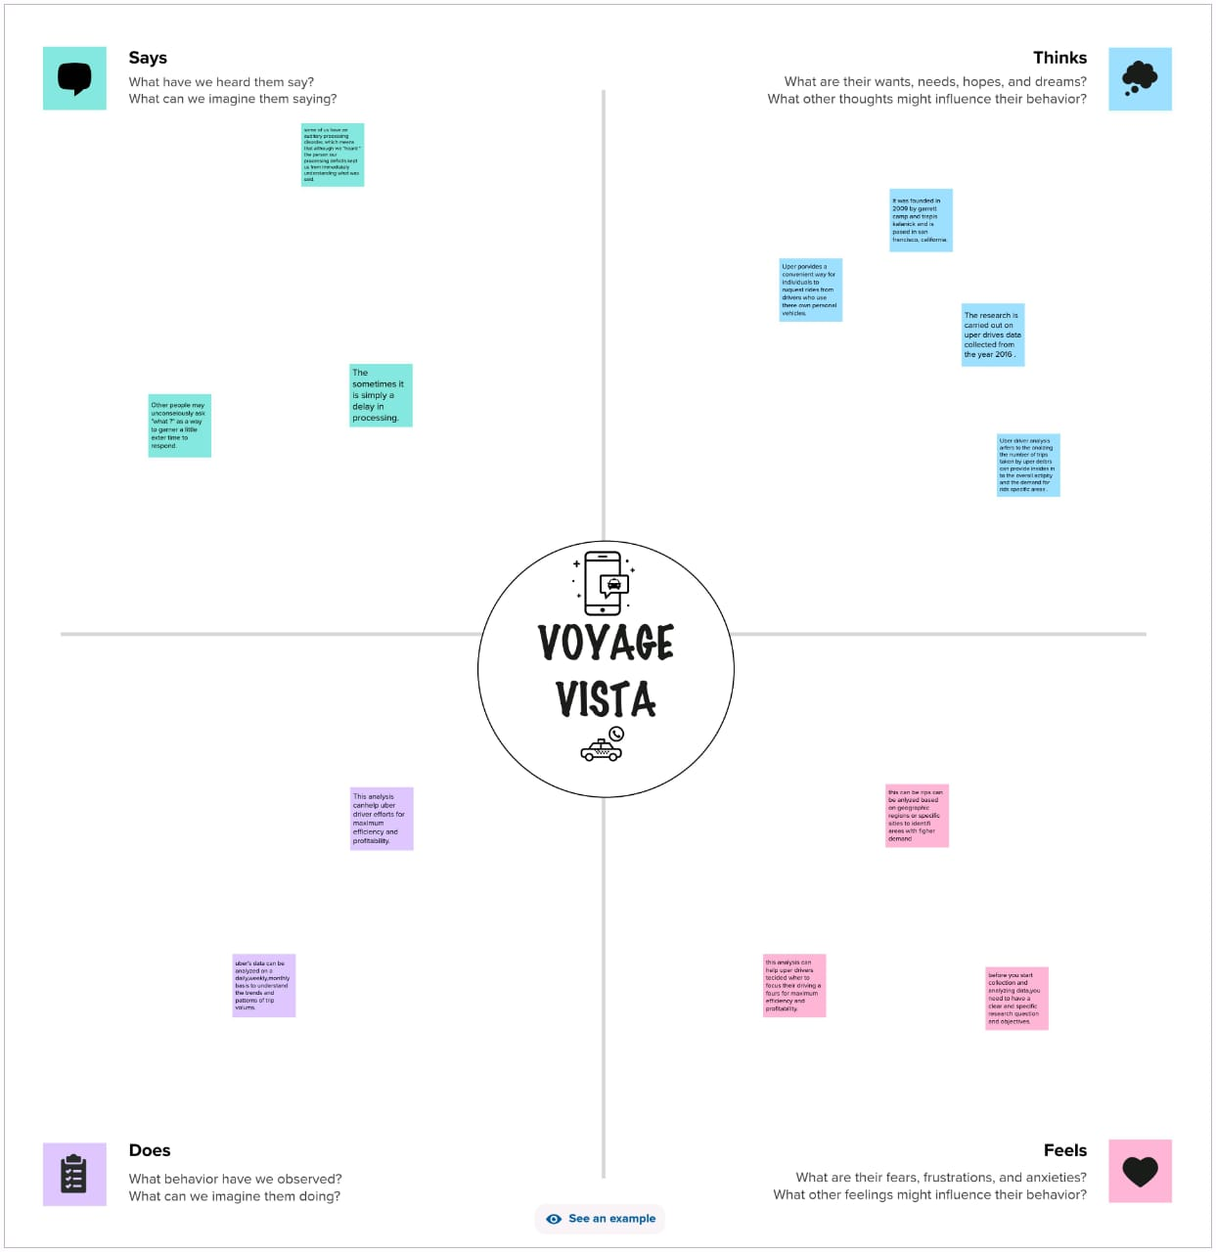

**2.2 IDEATION & BRAINSTROMING MAP:**

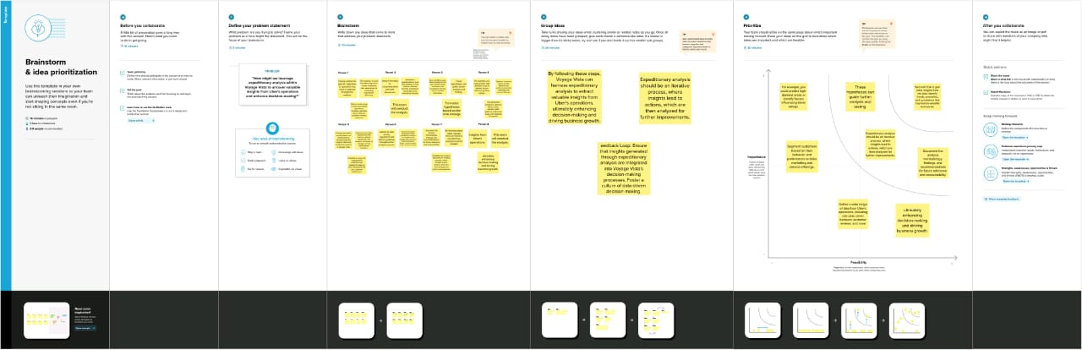

**3. RESULT :**

**Sheet 1 :**

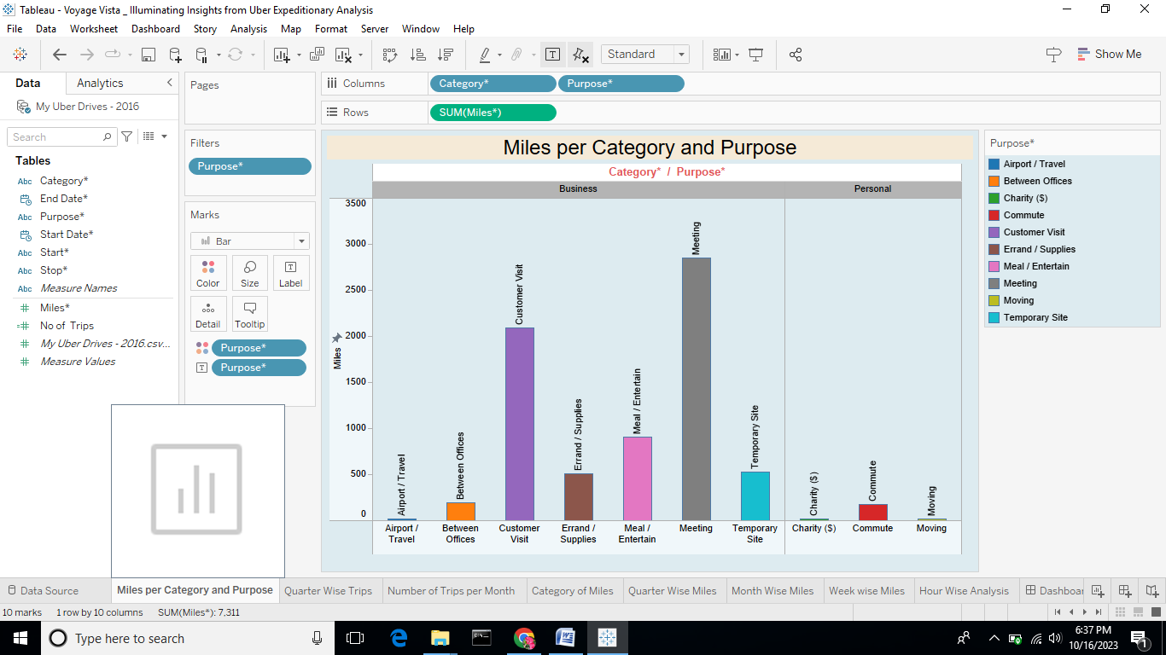

**Sheet 2 :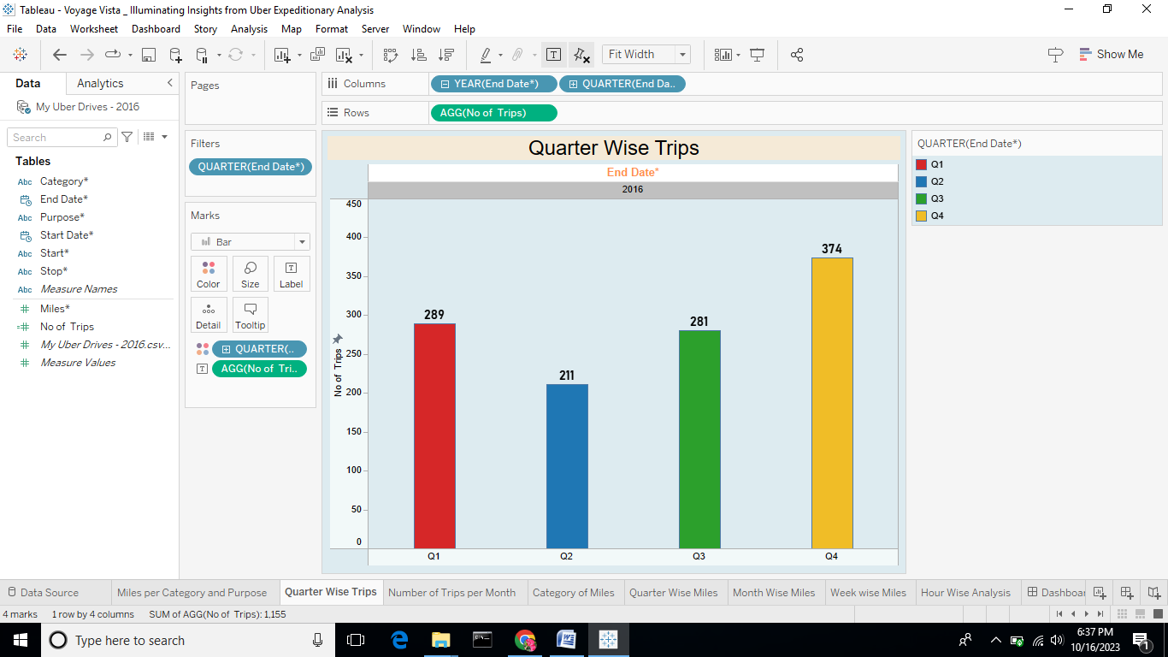Sheet 3 :**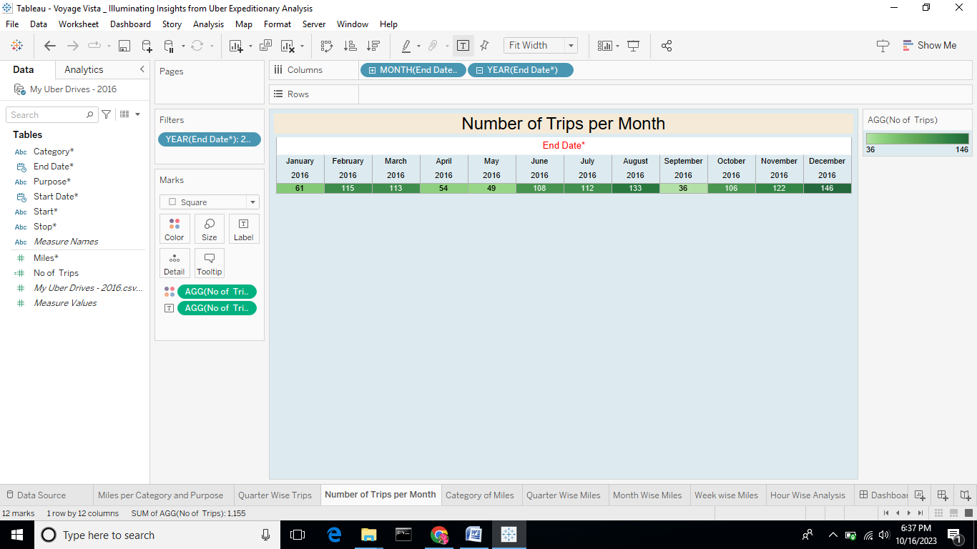

**Sheet 4 :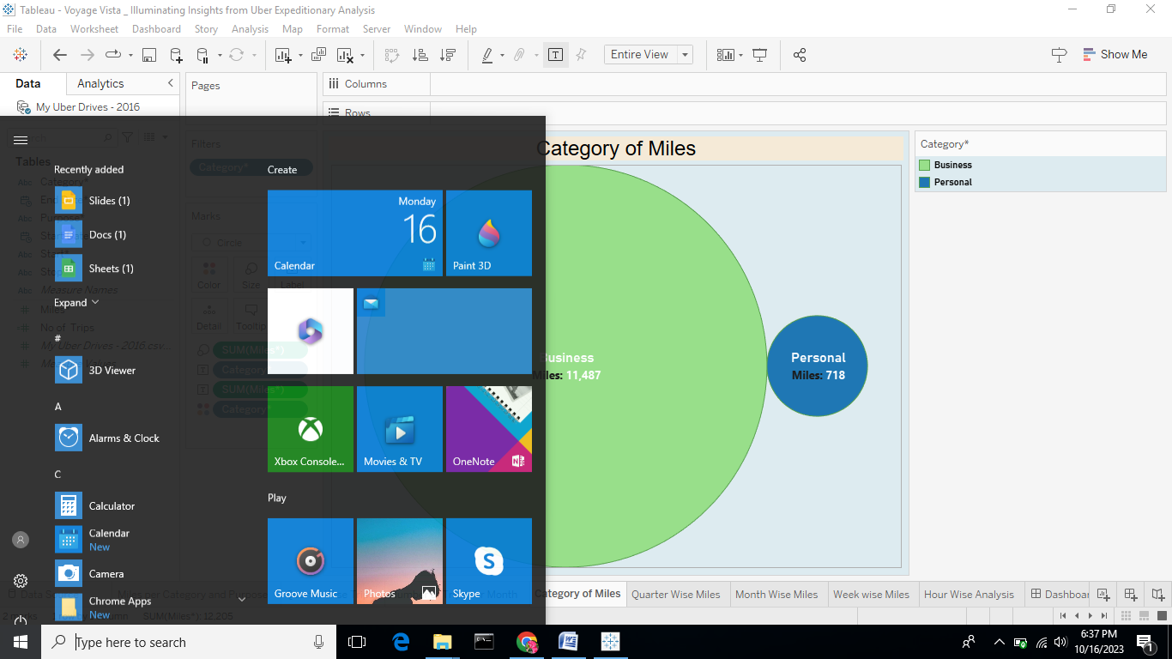Sheet 5 :**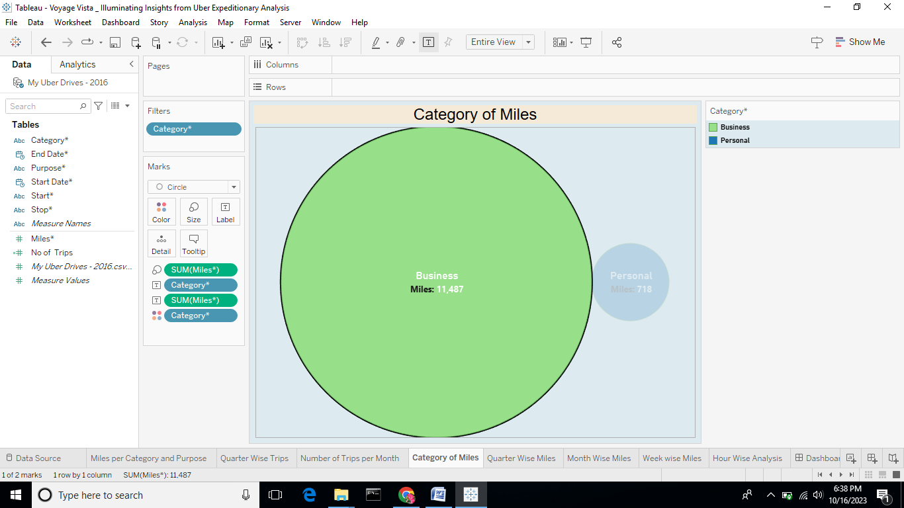

**Sheet 6 :**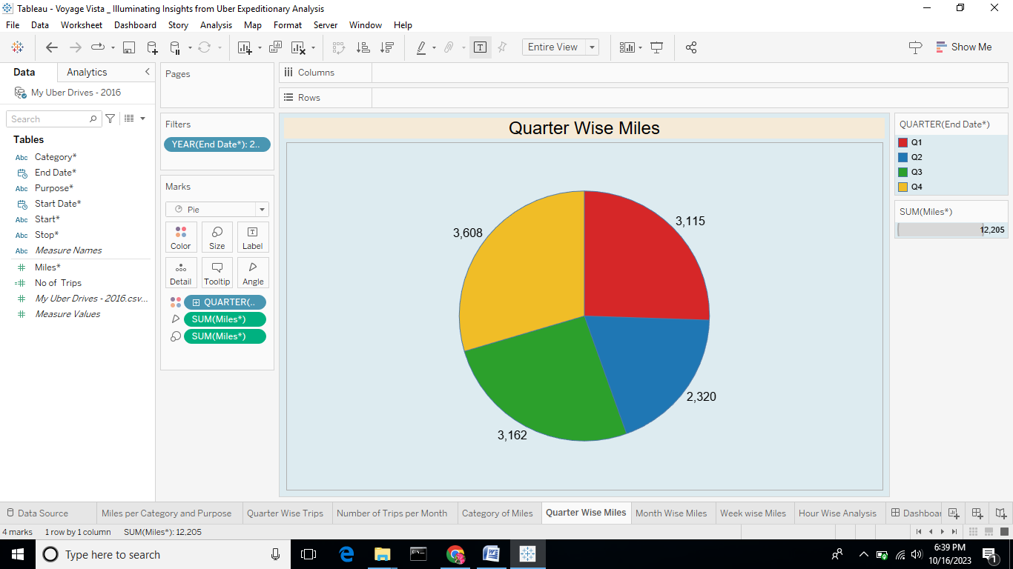

**Sheet 7 :**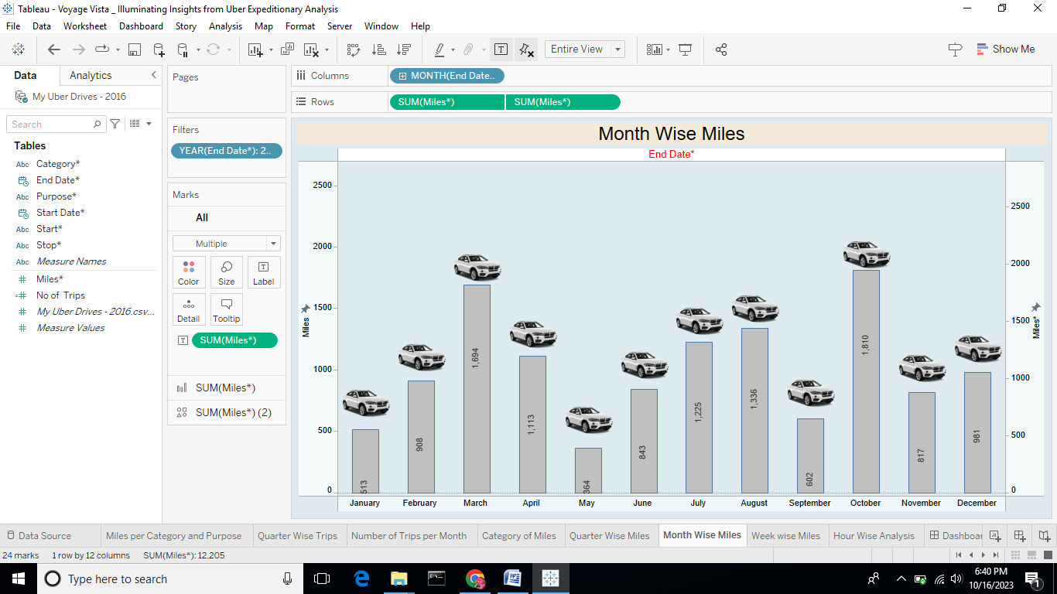

**Sheet 8 :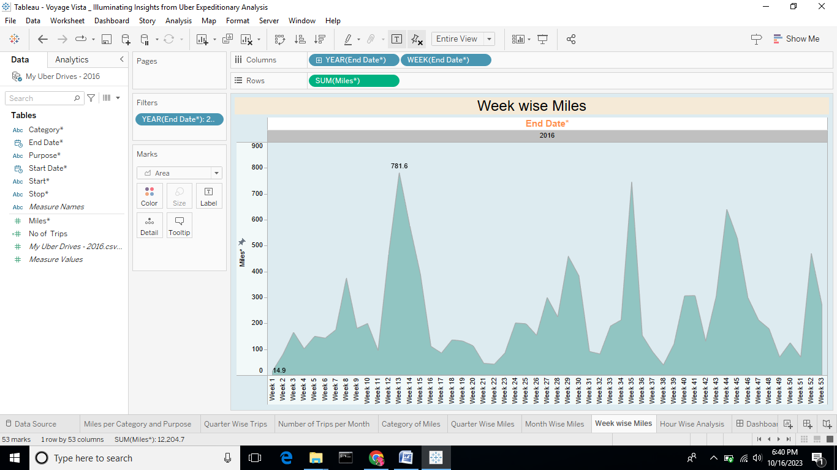Sheet 9 :**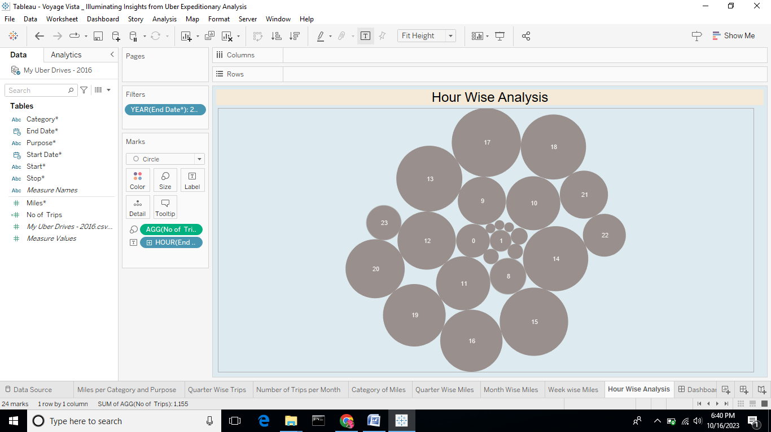

**Dashboard 1 :**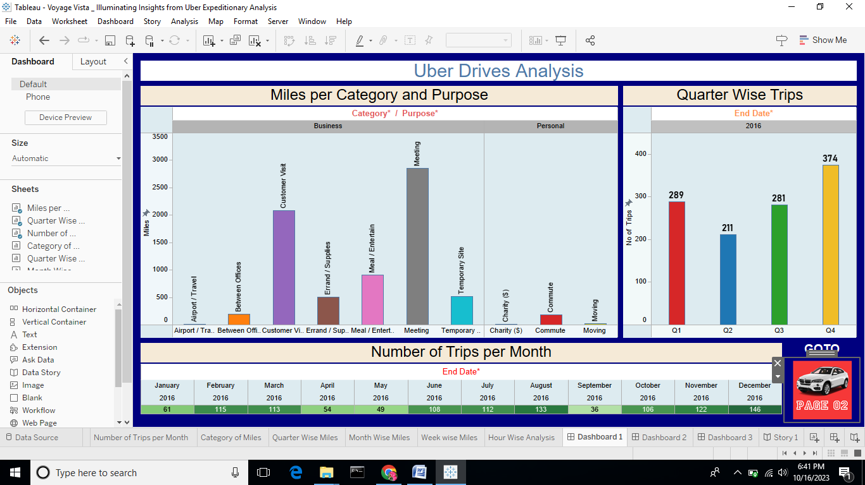

**Dashboard 2 :**

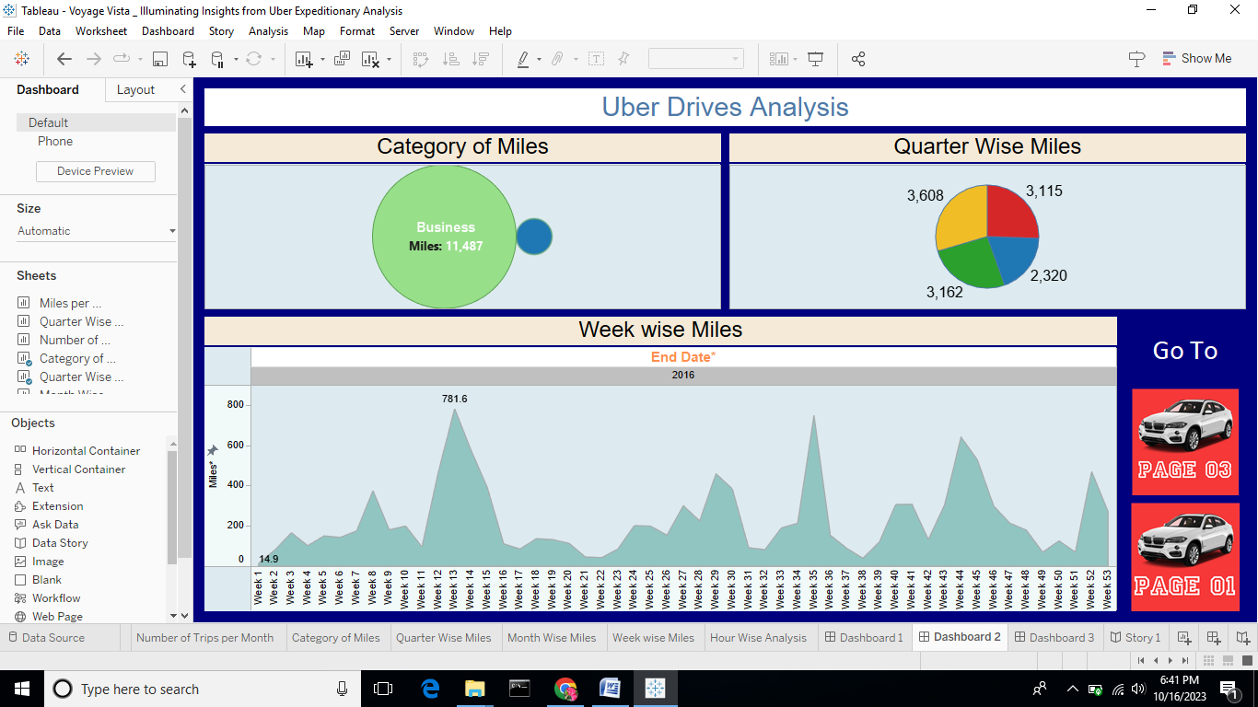

**Dashboard 3 :**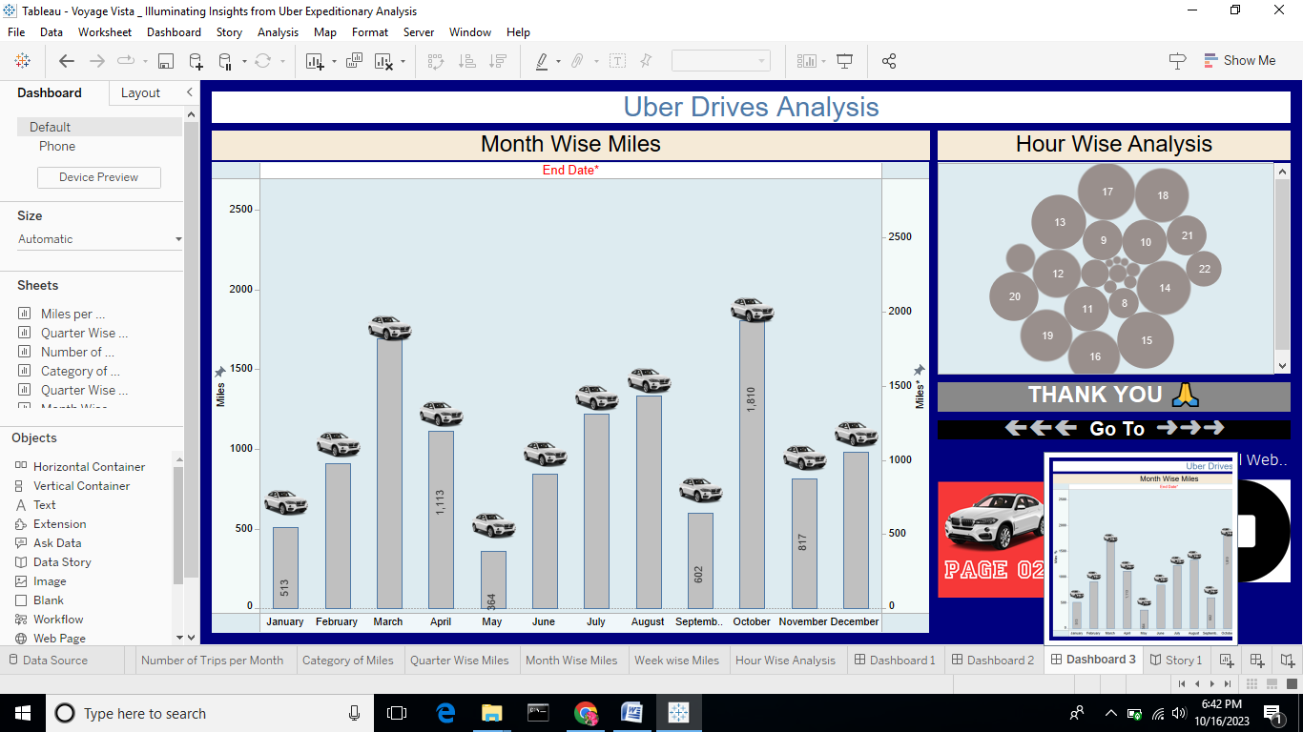

**Story 1 :**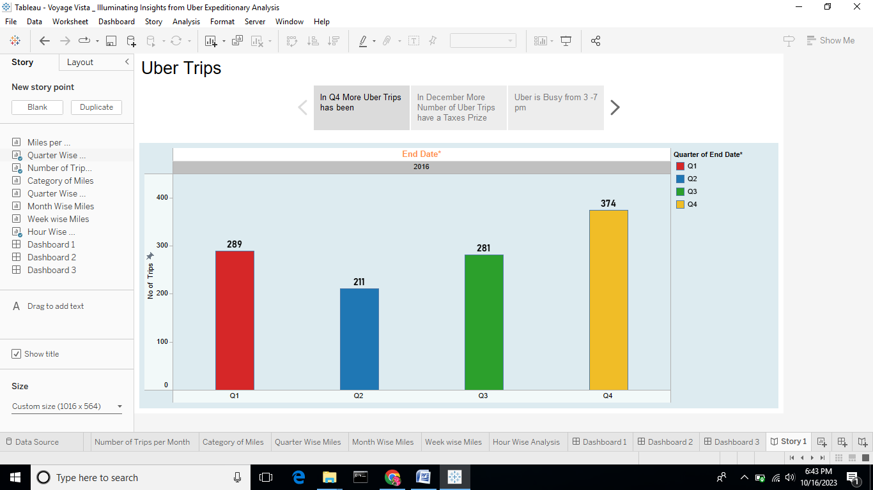

**Story 2 :**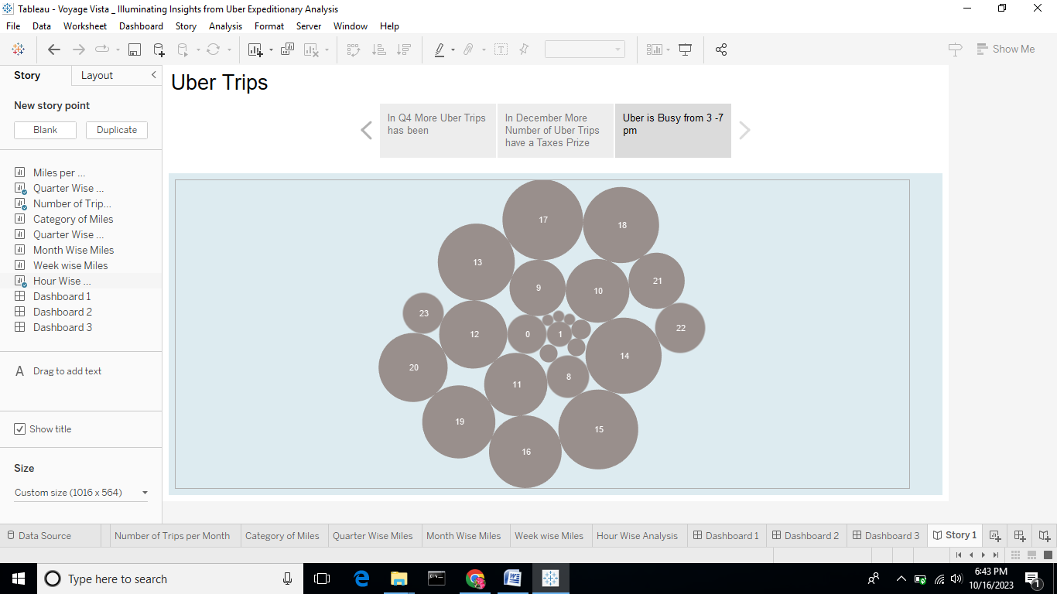

**Story 3 :**

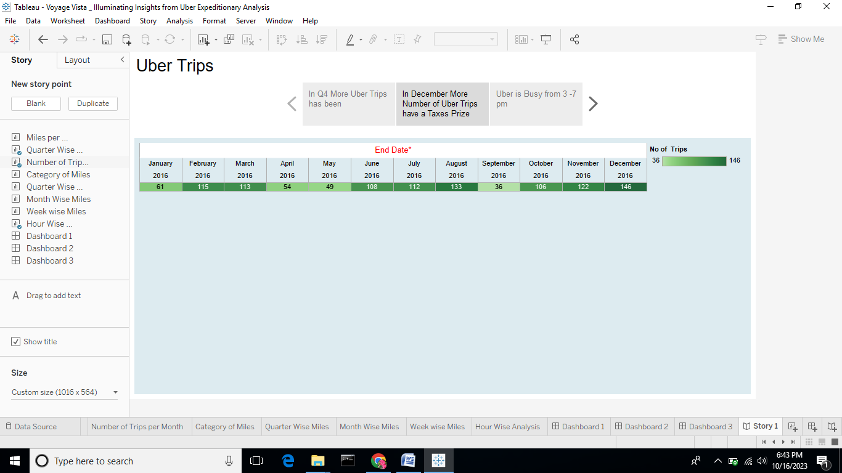

**4. Advantages and Disadvantages:**

**4.1 Advantages:**

1. Disruption of Traditional Industries: Uber disrupted the traditional taxi industry by introducing a more convenient and user-friendly transportation service. The advantage here is the ability to challenge established industries through innovative business models.

2. Efficiency and Convenience: Uber provides a convenient way for riders to hail rides, track them in real-time, and make electronic payments. This convenience can be translated to other industries looking to streamline processes and improve customer experiences.

3. Data-Driven Decision-Making: Uber heavily relies on data analytics to optimize routes, pricing, and driver incentives. This advantage highlights the power of datadriven decision-making in enhancing operational efficiency and customer satisfaction.

4. Global Reach: Uber's global expansion demonstrates the potential for scaling a successful business model to a worldwide audience. This scalability can be advantageous for businesses aiming for international growth.

5. Diversification: Uber's diversification into services like UberEATS and Uber Freight shows the potential for expanding a platform-based business into related industries, increasing revenue streams.

**4.2 Disadvantages:**

1. Regulatory and Legal Issues: Uber has faced significant regulatory and legal challenges in many cities and countries. Taxi associations and local governments have often argued that Uber operates unfairly and circumvents traditional taxi regulations, leading to disputes, fines, and even bans in some places.

2. Safety Concerns: There have been reports of safety issues, including incidents involving both drivers and riders. Concerns about driver background checks, the behavior of some drivers, and the safety of passengers have been raised.

3. Driver Classification: Uber has faced legal battles over the classification of drivers as independent contractors rather than employees. This classification has implications for benefits, workers' rights, and labor laws in various jurisdictions.

4. Fair Wages and Worker Conditions: Some drivers have voiced concerns about low earnings, especially when factoring in vehicle expenses and the lack of traditional employment benefits. This has led to discussions about fair pay and working conditions for gig economy workers.

5. Dynamic Pricing: While dynamic pricing (surge pricing) can be beneficial for balancing supply and demand, it has also been criticized for leading to high fares during peak times or emergencies, potentially taking advantage of passengers.

**Applications :**

1. Ride-Hailing: Uber's primary application is to provide on-demand transportation services. Users can request rides via the Uber app, and drivers pick them up and take them to their desired destinations. This service is available in numerous cities worldwide.

2. Uber Eats: Uber Eats is a food delivery service that allows users to order food from local restaurants and have it delivered to their doorstep. This service has become increasingly popular, especially in urban areas.

3. Uber Freight: Uber Freight connects shippers and truck drivers, simplifying the logistics and transportation of goods. It offers a platform for freight booking, tracking, and payment for both shippers and carriers.

4. Uber for Business: Uber offers a platform for businesses to manage employee transportation needs. This includes facilitating business travel, employee commuting, and expense management through the Uber for Business program.

5. Uber Health: Uber Health provides non-emergency medical transportation solutions for healthcare organizations. It helps patients get to medical appointments conveniently and reliably.

6. UberASSIST and UberWAV: These services cater to riders with disabilities or those who require additional assistance. UberASSIST provides drivers trained to assist passengers, while UberWAV offers wheelchairaccessible vehicles.

7. Uber Connect and Uber Direct: During the COVID-19 pandemic, Uber introduced these services to facilitate package and essential item deliveries. Uber Connect focuses on peer-to-peer package delivery, while Uber Direct helps businesses deliver products to customers.

**6. Conclusion:**

In conclusion, Uber has evolved from a disruptive ridehailing service into a versatile platform with a wide range of applications that extend beyond transportation. Its innovative business model, driven by technology and data, has not only transformed the way people move from one place to another but has also influenced other industries such as food delivery, logistics, and healthcare transportation.

Uber's applications have addressed various consumer needs, from convenient urban transportation to food delivery, freight logistics, and non-emergency medical transport.

While Uber has faced its share of challenges, including regulatory hurdles, safety concerns, and labor issues, it continues to shape the way businesses think about transportation and service delivery.

Its ongoing evolution, pursuit of innovations like autonomous vehicles and urban air mobility, and commitment to meeting consumer demands highlight its enduring impact on the modern economy.

**7. Future Scope :**

1. Autonomous Vehicles: Uber is investing in self-driving technology. The future may see autonomous Uber vehicles providing rides, potentially reducing labor costs and improving safety.

2. Urban Air Mobility: Uber Elevate, the company's vision for urban air mobility, aims to introduce flying taxis in select cities. This could revolutionize urban transportation by providing faster, congestion-free travel.

3. Sustainability: As environmental concerns grow, Uber may focus on offering more electric and eco-friendly vehicle options, as well as expanding its bike-sharing and scooter-sharing services to reduce carbon emissions.

4. Global Expansion: Uber may continue to expand into new markets and regions, especially in emerging economies, where ride-hailing and delivery services are in high demand.

5. Diversification: Uber may explore additional services and verticals to diversify its revenue streams further. This could include entering new sectors like healthcare, autonomous deliveries, or even financial services.

6. Enhanced Safety Measures: Continuous improvements in safety measures and technologies, including background checks, real-time safety features, and driver monitoring, are likely to be a priority.

7. Regulatory Engagement: Uber will continue to engage with governments and regulatory bodies to find common ground and establish regulatory frameworks that allow its services to operate legally and safely.

**8. APPENDIX**

**A. Source Code :**

